Geology 340 - Images of the Earth Name: _________________
Lab 1 - Latitude, Longitude, and Maps; or, White Guys who Travel
80 points
Part I: Eratosthenes
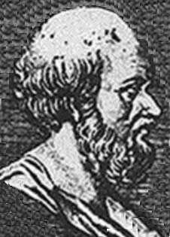
Eratosthenes made an extremely accurate estimate of the circumference and radius of the Earth from simple geometric measurements. (See the picture on the next page for the way he set up the problem). He had made several observations:

- The sun shone directly to the bottom of a deep vertical well in Syene (now Aswan) in Egypt at noon on the summer solstice.
- There was a vertical wall in Alexandria which cast a shadow
- Syene was about 787 kilometers from Alexandria

Eratosthenes took measurements on the shadow cast by the wall at noon on the day of the solstice. Nobody knows exactly what Eratosthenes' measurements were - the only record of his work is limited descriptions of it by others - but it might have been something like the diagram below at left.

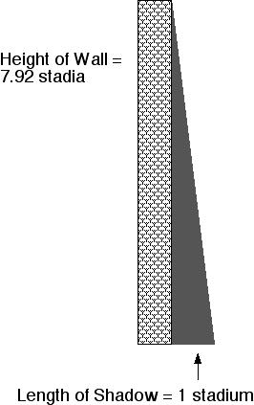
- Why is it important that the measurement be taken at the same date at both sites? (3 points)

- Does it matter that it is at noon? Why or why not? (1 point)

- Does it matter that it is on the solstice? Why or why not? (2 points)

- Why is it important that the measurement be taken from two places at about the same longitude? (3 points)
- From the measurements given in the figure above, what is the angle between the direction of travel of the Sun's rays and vertical in Alexandria? Show your work for this calculation (5 points)

Eratosthenes constructed his solution in the following way:
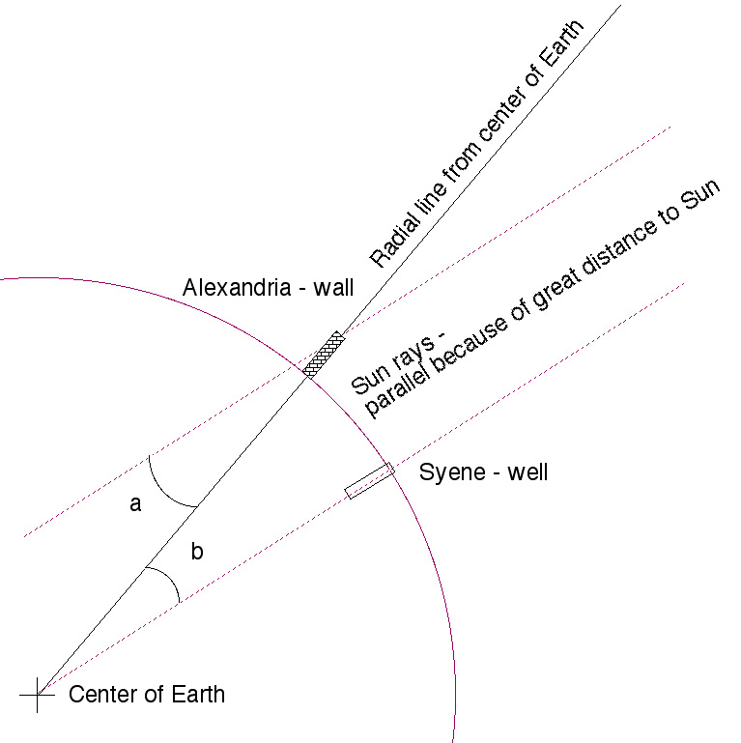
- How do we know that the ray passing through the well also passes through the center of the Earth? (2 points)

- How do we know that the vertical line passing through the wall also passes through the center of the Earth? (2 points)

- What is the relationship between angles a and b? Why? (2 points)

- Given the distance between Syene and Alexandria above (787 km), what is the Earth's circumference? (Hint: Use a ratio of angles and distances.) Show your work. (5 points)
- Based on your answer to #9 above, what is the Earth's radius? Show your work. Hint - it should be between 6000-7000 km (4 points)

- Using your result from #9, calculate the length of one nautical mile in kilometers. Show your work. Remember that one nautical mile is one minute of latitude. If everything works, you should get a little under 2 km. (4 points)
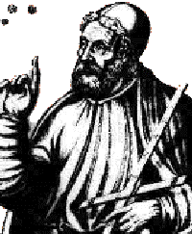

Part II - Ptolemy
Here is a version of Ptolemy's map of the Roman Empire. This particular version was reconstructed in 1482 from instructions in Ptolemy's writings on geography.
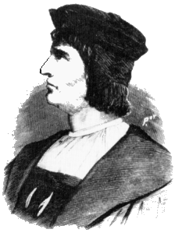
- Suppose you are Bartholomew Dias, a Portugese explorer who sailed around the Cape of Good Hope in 1487. What modification might you make to this map when you returned to Europe? Hint - look at the southern Indian Ocean! (3 points)

- How many meridians are drawn on the map? (2 points)

- The legend and scale (unreadable in this reproduction) indicates each meridian is separated by 5 degrees. How many degrees of longitude does Ptolemy's map claim to cover? (2 points)

- What is the actual longitudinal range covered by this map in degrees? You'll need to consult a modern map or globe. (3 points)

- What is the actual range in kilometers measured at the equator covered by this map? Hint: one minute of latitude = one nautical mile; how do latitude and longitude relate at the equator? Use your conversion factor for nautical miles and kilometers in #11 above. Show your work and how you set up the problem. (5 points)

- According to Ptolemy and his map, if the longitude range were what you say in #14 and the distance were what you found in #16, what would the circumference of the Earth be in kilometers? Show your work. (5 points)

- How does your answer to #17 compare to the actual circumference of the Earth you calculated above in #9? (2 points)

- Suppose Christopher Columbus is looking at this map (he did) and planning a voyage in 1492 or so (he did). He notes roughly 180 degrees of longitude between Spain and Western Australia. If the Earth is 360 degrees, then he should be able to go around the other side of the world (the side not shown on this map) through 180 degrees (or maybe less) and get to the east coast of Asia.
The catch: You know the map isn't really 180 degrees (see your answer to question 14).
The question: If Columbus travels west from Spain what he thinks is 180 degrees to get to somewhere near Australia, where would he actually end up? How did you figure this out? (4 points)

Part III - Santa Claus
Suppose you are a jolly endomorphic saint who has a thing for diminutive toysmiths and flying ruminants. You need to go from the North Pole to Greensboro (36°N, 80°W) to deliver a new paperweight to Jane Fernandes.

- What is the shortest path you can take to reach Jane’s house? (2 points)

- How many nautical miles will you have to travel to reach Greensboro along this path? (4 points)

Part IV: James Bond
Imagine you are an international spy on a big mission. You battle a large German thug on the international space station after being tied to a table and almost dissected by lasers, eaten by sharks, and speared by scuba divers. After you finally push Günther out the airlock and disable the MIRV warheads pointed at Washington, London, Moscow, and Boring, Oregon, you take the escape pod and re-enter the atmosphere, falling to the ocean.
Unfortunately, the landing knocks out the GPS in your two-way wrist TV. After cracking open of the capsule and pressing the red button that converts it to a speedboat, you notice (1) that it's nighttime, just before dawn, and that (2) the Southern Cross is at about 45° above the horizon. Exhausted, you fall asleep.
You wake with the sun blazing down on you from the highest point on its arc. After checking that your hair is still unflappably handsome and your tuxedo/evening dress neatly pressed, you glance at your watch, still set to International Space Station Time (Zulu time, or Greenwich Mean Time). It says 7:24 a.m.

- What is your current latitude? How did you find this? (2 points)

- What is your current longitude? Show your work. (5 points)

- What is the nearest land? (2 points)

- How far are you from this land in nautical miles? Show your work. (3 points)

- If your speedboat can travel at 15 knots, how long will it take you to get to land? Show your work. (3 points)

