Name:
Geo 340 – Lab 5 (100 points)
Doing more with ArcGIS – Attribute data

This lab we’ll continue to work with ArcMap. The ArcGIS software is only installed in our classroom and on some of the other computers nearby (including the Almy lab), so you won’t be able to access it from other places on campus.

Preparation: This week we’ll be using the same basic demographic and shape data as last week. If you’ve already installed it, you’re all set. If you haven’t, go to the course web site and download the file called Lab 4 Data. This is an installer; you’ll need to extract it onto the C: drive of the computer you’re using (the default folder c:\temp is OK, or you can put it on your H: drive share space to have it accessible on other computers).

Basics: Last week’s lab gave instructions for starting a map and adding data. If you need to brush up on that, please see last week’s handout.

Turning in stuff: For the written questions, write your own answers and turn them in. It might be easiest to just type them into this document, but I’m OK with whatever you prefer. For maps, screen capture them (Print Screen key, or hold Alt-PrintScreen to just get the Arc window) and paste them into this Word document, then submit the whole document to me on Canvas.

Part I: Using attribute data

Tasks

Task I: African Americans by State

- Create a map of the percentage of African-American population compared to (i.e. normalized by) the total population by state. Use a color-shaded map with categories split by natural breaks (Jenks) with 5 divisions.

- The “natural breaks” calculation tries to divide the distribution of values into a number of categories that represent clusters of data points. Look at where the natural breaks are selected for the map you made in #1. Are the distinctions between the breaks meaningful and appropriate for the data set? Explain. (4 points)

- Go into the Symbology section, click on the Classify button, and look at the histogram of possible values. How many significant “natural breaks” (spaces between clusters of data) in the histogram do you see? How many clusters does that make? (2 points)

- Change the Jenks natural breaks number of categories to the number of clusters you saw in #3. TURN IN THIS MAP AS MAP 5-1. (6 points)

- Did the computer pick the same breaks you did by eye? What are the differences? (3 points)

Task II: African Americans by County

- Create a new map of the percentage of African-American population compared to the total population, this time by county. Use a color-shaded map with categories split by natural breaks with ten divisions.

- What does this more detailed county-level map show that the less detailed state-level map does not? (4 points)

- Would a dot-density map better portray this type of data (percentage African-American by state or by county)? Why or why not? (4 points)

- Add city locations and city demographics data to the map. Make the size of the dots for the cities represent the population of the cities. TURN IN THIS MAP AS MAP 5-2.
(10 points)

- Is there any correlation between city size and percentage of African-Americans? Where do these two data sets seem correlated? Where are they not correlated? (4 points)

Task III: Asian Americans by County

- Now repeat task 2, but do the percentage of Asian-Americans in the total population. TURN IN THIS MAP AS MAP 5-3. (5 points)

- What geographical trends do you see in the data? (4 points)

Task IV: African Americans compared with Asian Americans

- Create a map that shows the ratio of African-Americans to Asian-Americans by county. TURN IN THIS MAP AS MAP 5-4. (5 points)

- Is this a useful ratio to use? Why or why not? What (if anything) is it telling you? What questions could it answer? (6 points)

Part II: Importing Attribute Data

Task V: Nuclear energy

- Find a listing of nuclear reactors by state on the Internet. Where’d you find this information? (3 points)

- Find a listing of total electricity produced (or consumed) by state on the Internet. Where’d you find this information? (3 points)

- In Excel, create a table with at least four columns: 1) state name or abbreviation, 2) the number of reactors operating in the state, 3) the total electricity produced by (or generating capacity of) these reactors (the Energy Information Administration or the Census has this information), and 4) the total amount of electricity generated (or consumed) by the state. Print and attach or send this table by e-mail or submit on Moodle. (12 points)
- Save this table in a format that ArcGIS can read (Comma-Separated Values format – CSV- is good). Using ArcMap, join the data to the state shape file, and create a map showing the number of reactors by state. TURN IN THIS MAP AS MAP 5-5. (5 points).

- Create a map showing the total nuclear electricity produced (or consumed) by state.
TURN IN THIS MAP AS MAP 5-6. (5 points).

- Create a map showing the percentage of total electricity produced by nuclear reactors. TURN IN THIS MAP AS MAP 5-7. (5 points).

Part III: Seven Wonders

The seven wonders of the ancient world were celebrated feats of architecture. Of the seven, only the Pyramids at Giza still exist today.

- In a spreadsheet file, make a list of these wonders, then make your best estimate their latitude and longitude. Save it as CSV (it works better for this). Make sure to include column headings.
- Find a shapefile of all modern countries. Add that as your basemap. Make the land pale green. Add country name labels. Make them subtle.
- Then, import your latitude/longitude file as a layer using File Add Data Add XY Data. When you import, choose the coordinate system “ITRF 1988” from Geographic Coordinate Systems World. This will ensure your latitudes and longitudes are treated in degrees.
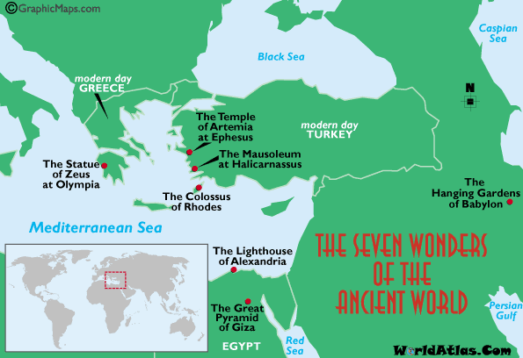
- Add labels on your points with the names of the Wonder. Make them obvious. Make the dots red and big enough to see easily.

You should end up with a map resembling the one at right. Take a screen capture and add it here as Map 5-8.

10 points total.

