Name:

Geo 340 - Lab 6: Georeferencing Raster Data Sets

Guilford College, Napoleon in Russia, and Ptolemy

Part I: Guilford’s Map

Step 1: Vector data
- Go to the course web page, download the data file for Lab 6, and unzip it. This has several shape data files which you should add to a project. You’ll find that the roads obscure the other layers, so make sure to put them on the bottom of your Display list so that they’re drawn on the bottom. You probably want to turn off buildings (click the checkbox next to them) for now – it takes the computer a lot of memory to draw them.

- Find Guilford College on the map. You can use Bryan Boulevard and the airport as landmarks. Zoom in so you can see Guilford’s campus and Friendly and New Garden.

Step 2: Adding the raster image
- Download the aerial photo of Guilford’s campus from the course web site. It’s a JPEG file.
- Add the image into your ArcMap project. You should be able to add it cleanly, but you may not see it at first. That’s OK.
- You need to position the image in the right place. Click with your right mouse button on the toolbar at the top, and add the “Georeferencing” toolbar.
- Click on Georeferencing… and pick “Fit to Display” – you may see your picture now, but it may be partially or completely hidden by the other layers.
- If you can’t see the image, go to “Display” mode on the little tabs to the lower left, and move the image up to the topmost layer
- Right-click on the image file, pick Properties, and find the Transparency box. Make the image 50% transparent
- Click on the little tie-making button (“Add Control Points” - plusses connected by a line) on the Georeferencing toolbar. This lets you tie points on the image to points on the vector map.
- Create enough control points with the landmarks depicted in the map to make the tour map line up well with Guilford’s campus. Use a 1st-order polynomial fit.

NOTE: You may make a bad tie, or too many ties. In this case, open up the control point table and delete the bad ones. This is a little clunky, but you can usually get it to do what you want.

- Once you have a few points, try setting the map to a 2nd-order polynomial fit. Does that improve or harm your georeferencing fit appearance? What is the difference between this method and the 1st-order polynomial? (4 points)

Screen-capture your best-fit georeferencing and submit it with this lab as Map 6-1.
(10 points).

Part II: Napoleon in Russia
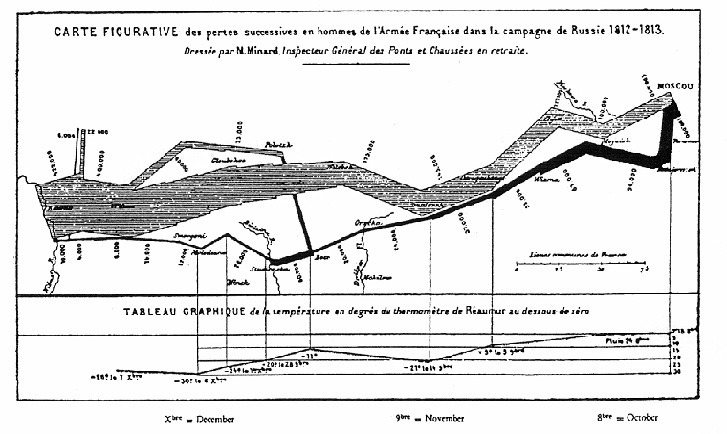
Charles Minard was a famous engineer, statistician, and maker of diagrams. One of his most famous images is the upper one on the right, showing the path taken by Napoleon’s army during his disastrous Russian campaign in June-December 1812. A modern re-drafting is shown below, with clearer labels.

- How many different variables (types of information) are represented on this map? What are they? (6 points)

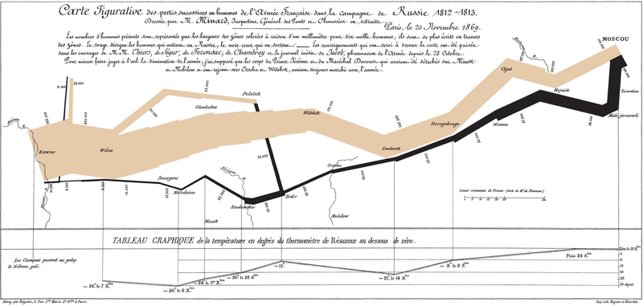

Wikimedia Commons redrafting https://commons.wikimedia.org/wiki/File:Minard.png

Hey, I know! Let’s insert Minard’s map (top one, above) as a raster dataset into an ArcGIS map. This will take several steps:
- Open ArcMap
- Create a new map, but this time use a template. Click on Templates, World, and pick Europe.mxt
- Zoom in on the region between Poland (where Warsaw is) and central Russia. Make sure to include Vilnius and Moscow (transliterated as Moskva here).
- You may wish to add the simplified world national boundaries file to your map. It’s available on the course web page.
- Now visit the course web site and save a copy of the Minard image to your computer. Choose the one that says “USE THIS ONE.” You should click on the image with your right mouse button, pick “Save Picture As…” and choose a place to save the image.
- This image is a PNG image. Convert it to a JPEG image. There are many ways to do this (e.g. Paint or another image processing program). A quick and easy way is the converter at the site go2convert.com.
- Go find the images on your computer and look at the file size of the two image files. What are they? (2 points)

PNG:

JPEG:

Why are the file sizes different, and what makes them different? Remember that the PNG and JPEG formats are different in several fundamental ways. (5 points)

- Now add the image (PNG version works best) into your ArcMap project. You should be able to add it cleanly, but you may not see it at first. That’s OK.
- You need to position the image in the right place. Click with your right mouse button on the toolbar at the top, and add the “Georeferencing” toolbar.
- Click on Georeferencing… and pick “Fit to Display” – you should see your picture now, but it will probably be partially hidden.
- Make sure you’re in “Display” mode on the little tabs to the lower left, and move the image up a few layers to just under the country boundaries.
- Click on the little tie-making button (“Add Control Points” - plusses connected by a line) on the Georeferencing toolbar.
- Tie Moscow on the image to Moscow on the map. Napoleon reached Moscow, but the Russians had evacuated with everything of value long before they arrived and set the city on fire.
- There’s a table of locations on the website that contains locations of places mentioned on the Minard Map. Download that file (MinardTable.csv) and open it to take a look.

We can add the table as a shape file by following this protocol:
- Add MinardTable.csv to your ArcMap project
- Choose “Add XY Data” from the File menu
- Choose MinardTable as the data source
- Correctly pick Longitude and Latitude as x and y values
- You’ll need to change your coordinate system to add these as latitudes and longitudes. To do this, use the Edit button, pick the Geographic Coordinate Systems, World, and WGS1984 as your frame of reference.
- If that went well, you should see the cities plotted in Eastern Europe. If not, they may be elsewhere, like in Africa.
- Label your cities using Properties Labels
Not all city locations may be correct – I was going from modern locations on the web. Use the ones that are helpful, ignore the ones that aren’t.
http://www.napoleonic-literature.com/1812/1812.htm
The Dnieper River is shown on both maps about halfway through, at Mohinow. It may also be useful for tiepoints. If you need more help getting your locations, there is another redrafted version of Minard’s map with national borders available for viewing on the course website.

NOTE: You may make a bad tie, or too many ties. In this case, open up the control point table and delete the bad ones. This is a little clunky, but you can usually get it to do what you want.

- How many control points does it take to make a good match? Do more points help or hurt the process? Why? (5 points)

- Try setting the map to a 2nd-order polynomial fit under the Georeferencing menu. You’ll need at least six control points to make that available. Does that improve or harm your georeferencing fit? What is the difference between this method and the 1st-order polynomial? (4 points)

Screen capture your best-fit georeferencing and submit it with this lab as Map 6-2
(10 points).

Part III: Ptolemy Revisited

- Download the version of Ptolemy’s map (this was redrafted in the 15th century) from the course website.
- Start a new project using the World Robinson template.
- Georeference Ptolemy’s map to the World Robinson template. You won’t be able to identify or use all of Ptolemy’s land masses very well, but do your best; Europe and the Mediterranean should be in pretty good shape.
- Which works better, a 1st order or 2nd order polynomial? How about a 3rd-order one or a Spline or the Adjust option? (3rd-order and Spline will require lots of tie points). Which do you choose as your best fit, and why? (5 points)

Screen capture your best-fit georeferencing and submit it with this lab as Map 6-3
(10 points).

