**Name:**

**Geology 340: Images of the Earth**

**Lab 8 – 3D Visualization in ArcGIS**

In this lab we will explore some of the 3D visualization techniques provided in ArcScene.

**Part 1: Guilford Campus (40 points)**

1. Download the Lab 8 data from the course web page
2. Open ArcScene
3. Add the items from the Guilford folder to your ArcScene – this should be:
   1. Guiltin – the TIN file with elevations
   2. 2-foot topographic lines
   3. Lake
   4. Rivers
   5. Buildings
   6. Paved Areas
   7. Roads
4. Set the base height (under properties) for all of the data sets to the “Guiltin” data set
5. Set the buildings to extrude to about 30 feet
6. Pick appropriate colors for all of the features
7. Fly through campus and have fun

**Turn in the following:**

1. An aerial view of campus from the Frank building looking across campus
2. An aerial view of campus from the college lake looking across campus

The above will get you 32 of the 40 points for this part.

**Extra activities** – do either of these for the final 5 more points (an A grade):

1. Take the Guilford College aerial photo from the web page, georeference it using the techniques from Lab 6, and drape it over the TIN above. Send me a picture of it draped.
2. Create an animated fly-through of the campus with at least 10 stops. Show me your movie

**Part II. Earthquakes (40 points)**

1. Find a shapefile of world countries. Load that into ArcScene.
2. Go back to the USGS Earthquake site we used in class. It’s here:

<https://earthquake.usgs.gov/earthquakes/search/>

Choose an area near the Peru-Chile trench. Download earthquake data along the trench, such that your settings for dates and sizes produce at least a few hundred points.

1. Using the depth field in the table, plot these earthquakes as points in ArcScene. Give them a negative scaling factor so the depths are shown properly and not stretched out too much. If you do this right, you should see them increasing in depth as they go further under South America. That’s because this is a subduction zone, where the oceanic plate underlying the southeast Pacific, called the Nazca plate, is being forced under the South American continent.

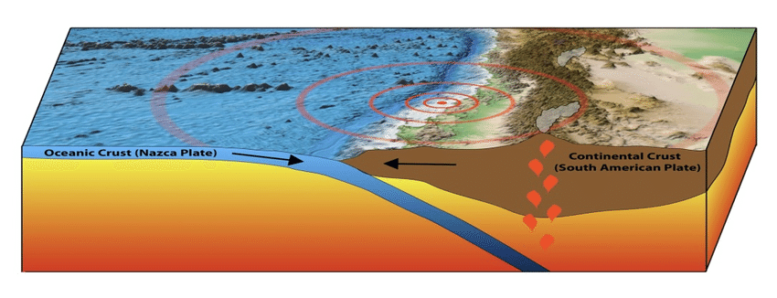

1. Take a screen capture of your points in Arc Scene (10 points)
2. Do a similar plot for the Aleutian trench near Alaska and submit a screen capture. (10 points)
3. Do a similar plot for California (10 points). This one shouldn’t show much of a depth trend, and the earthquakes shouldn’t be as deep, because there’s no subduction here.
4. For one of the two trench areas (Aleutian or Peru Chile) your choice), create an interpolated surface using the Raster Interpolation tools under the 3D Analyst toolbox. Experiment with the surface types (IDW, Spline, Nearest Neighbor, etc.), and pick one you think looks the best. Submit a screen capture. (10 points)

**Part III. Miami (20 points)**

1. Download the digital elevation information for Miami, Florida, provided here:

[**Miami elevations**](https://drive.google.com/file/d/12ycsqd430Kca6MgOWsVPLlfoLGyluaUU/view?usp=sharing)

1. View it in ArcScene. You’ll want the shapefile and the bigger image file (not the thumbnail). You may want to set the vertical scaling factor up a bit to show the different elevations better. Note that some parts of the city are already under sea level.
2. Most scientists suspect that we will experience on the order of one meter of sea level rise compared to preindustrial times due to global warming within the next 50 years. Some say it may reach two meters. Use Categories and Manual divisions under Symbology to show risk warnings with bright colors for all areas of Miami under 1m and under 2m to show where sea level rise might threaten parts of this city. **Hint:** You’ll want to consult the documentation in the data file to figure out what the vertical units of the data are (Feet? Meters? Kilometers? Miles?)
3. Take a screen capture of your risk map and turn it in (20 points)